**Design Documentation**

**ER DIAGRAM (Entity Relationship)**

***Entities (and its attributes):-***

* Donors
* Name
* AadharID
* ContactNo
* PointsScored
* NGO’s
  + NGOName
  + RegistrationID
  + WebsiteLink
  + ContactNo
  + Address
  + Description
  + Requirements

Products

* Category
* Name
* Amount

***Relationships:-***

* Donor donates to NGO
* NGO receives Products
* Donor donates Products

***Hence, the ER diagram looks like:-***

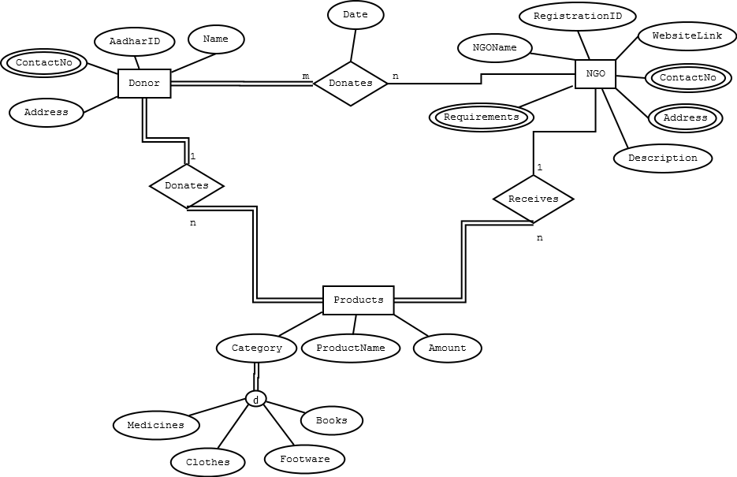

**Use Case Diagram**

1. ***LOGIN***
   * + Users: NGO, Donors
     + Type: Primary
     + Description: Users need to login in order to donate or receive. It confirms your address which helps in searching the nearest NGOs in case of donors and it helps checking the authenticity of the NGOs.
2. ***SEARCHING***
   * + Users: Donors
     + Type: Primary
     + Description: Donors can search for nearest NGOs according to the things that they’re donating. It helps them to donate using minimized efforts.
3. ***POINTS SYSTEM***
   * + Users: NGO, Donors
     + Type: Secondary
     + Description: All the registered users will get points when they donate or receive something. There can be monthly or yearly rewards to those who scored maximum points. This feature primarily increase the interaction between users and application.
4. ***NEWS FEED***
   * + Users: NGO, Donors
     + Type: Secondary
     + Description: This Part of application gives latest news about the current trends in NGOs and the success stories of NGOs when they do something good. This will increase everyone’s interest in the application.

Activity Model

***There will be a slight difference when it comes to activity diagram of Android application and web application. The reason for this is that registering and logging in into an android application at start up is normally preferred, while logging in into a web application is not preferred.***

***ACTIVITIES:-***

* **Login**
* **Register**
* **Searching**
* **Booking**

***Mobile Application Activity Model:-***

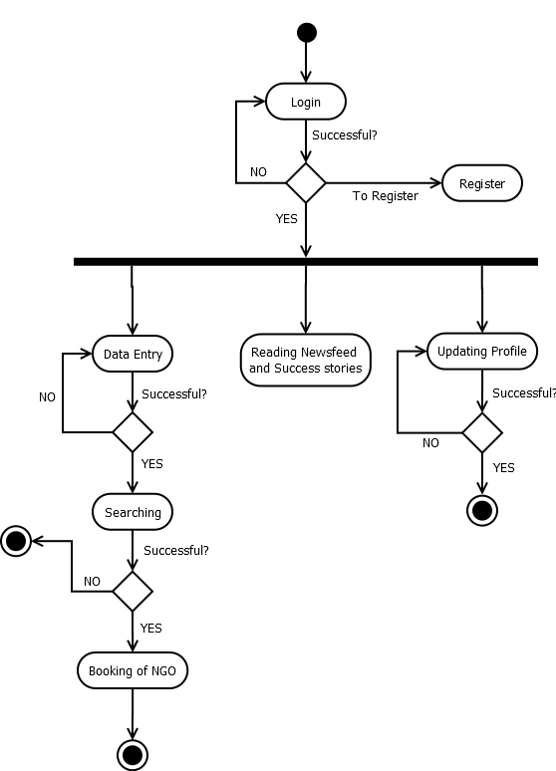

***Web Application Activity Model:-***

